Ethnography of Northeast High School

Aaron Dallaire
Nina Mauche
Claire Wang
University of Pennsylvania
School and Society
September 16th, 2013

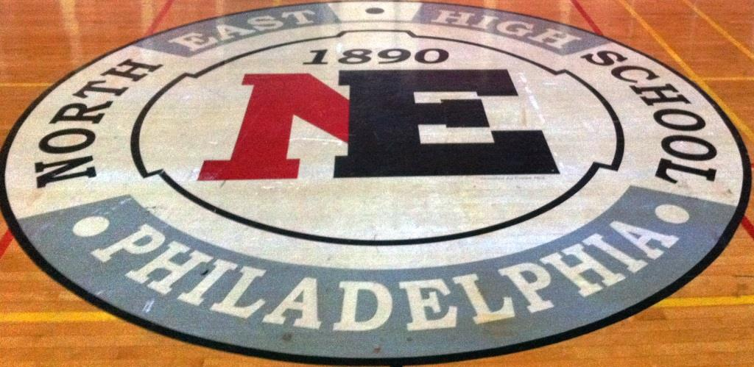
Descriptive Review of the Physical Neighborhood Surrounding the School
Northeast High School is a comprehensive neighborhood high school located at 1601 Cottman Avenue in the Rhawnhurst neighborhood located in Northeast Philadelphia. Northeast High School is surrounded by Cottman Avenue, Algon Avenue, Summerdale Avenue, Glendale Avenue, and Faunce Street. The building is three stories tall, and was completed in 1957, however, the school was established in 1890 at a different location. Prior to moving to its current location, Northeast High School was located at 8th Street and Lehigh Avenue. The school faces Cottman Avenue, the main entrance is parallel to Algon Avenue and leads to the auditorium and main office. Although there are many doors lining the entire perimeter of the school, students are only allowed to enter through certain doors, namely those entrances that are secured with metal detectors and guards.
Northeast High School is comprised of nine Small Learning Communities (SLC). Freshman students begin in either the 9th grade or 9th grade success SLC. Students then choose their SLC before entering 10th grade. They select from the following SLC programs: Magnet, International Baccalaureate (IB), Academic English Program (ALP, also referred to as English for Speakers of Other Languages (ESOL) or English Language Learners (ELL)), Health and Medical, Arts & Education (A&E), Applied Visual and Interactive Design (AVID), and Liberal Arts (Northeast High School, Programs, 2011). They offer over twenty five Advanced Placement (AP) courses which any student can choose to take. Theme-related electives are only available within one’s SLC. Most of the Small Learning Communities are situated throughout the building although the Magnet and AVID SLCs are located exclusively in the basement of the building.
Physically, the building is designed in the shape of a figure “8” with additional wings attached. Because Northeast High School is built into a hill, what seems like the first floor of the building is indeed the basement. Due to the picqualar layout of the building, there are entrances to the school from both the basement and the first floor on Glendale Avenue and Algon Avenue, respectively. The classroom numbers are organized with the rooms starting with “0” in the basement, “1” on the first floor, and “2” on the second floor. The even numbered classrooms are on one side of the building and odd numbers on the other. There are obvious signs of aging, which are prevalent throughout the building, including chipping paint, water stained ceiling tiles, and rusty stairwells. Most hallways are lined with banks of lockers and mismatched paint schemes. Further, all of the sinks in the lavatories have warnings to not drink the water. One of the first warnings a faculty member at Northeast High School gave was to never drink the water from any fountain. Although many classrooms are equipped with air conditioning units, in general the air conditioners do not work and open windows and fans are used to cool down the classrooms.
The campus is comprised of a sprawling athletic complex including a baseball field, a soccer field, utility field, four tennis courts, and a Field Turf football stadium surrounded by a track complete with lighting for evening games (see Image 1). Due to the high quality of their athletic facilities, Northeast High School is a “supersite” and therefore used by teams across the city. Furthermore, the football stadium is not exclusively used for football, but it is also used for other varsity sports including soccer and field hockey. Additionally, Northeast has three indoor gymnasiums, including one that is used exclusively for varsity sports. Hung on the walls of the varsity gym are the banners and pennants that Northeast has accumulated throughout the years (see Image 2). Some of these banners dated back to the early nineteen hundreds and include a wide range of traditional high schools sports such as football and basketball, as well nontraditional high school sports such as bowling and gymnastics. Northeast High School currently has one of the most wide-ranging selections of extracurricular activities and clubs in the region. They offer over 20 boys and girls sports teams and over 60 extracurricular activities that range from leadership groups to teen parenting support (Philadelphia Public School Notebook, 2012).
In order to better understand the neighborhood in which we will be student teaching, we made observations and interviewed community members of the immediate neighborhood. We defined the immediate neighborhood as the intersection of Faunce Street and Algon Avenue to Bleigh Avenue to the intersection of St. Vincent Street and Pennway Street, to St. Vincent Street and Algon Avenue, southeast along Cottman Avenue to Glendale Avenue to Summerdale Avenue, to the corner of Faunce Street and back to Pennway Street (see Image 3). This gave us roughly a three by two block area to observe.
During our neighborhood walk we noticed a mixed use neighborhood comprising of both commercial properties and residential properties. The residential properties consisted of single-family homes, as well as multi-unit residences including row houses and small apartment complexes. Most of these residential properties had outdoor space, which usually included at least a small lawn. In general, these outdoor spaces were well kept and neatly maintained. We did not observe excessive trash on the sidewalk or in any of the yards that we observed. Further, many of these residential properties had driveways and/or garages. We did notice many cars parked on the street. The cars we saw were comprised of both early and late models. The neighborhood also included a community center, the Jardel Recreation Center. The Jardel Recreation Center consists of a building with an indoor pool, as well as many athletic fields, including a softball field, a luxury we did not observe on the school grounds of Northeast High. We also observed three different churches including a Pentecostal church, a Philadelphia First Church of the Nazarene, which advertised bilingual services on Sundays and included The Little School Daycare, and a Philadelphia Gospel Hall.
Commercial activity in the neighborhood consisted mostly of eateries and gas stations. Included in the businesses that surround the school are a Fellah Auto Group, a 7-11 gas station with attached market, a Toyota car dealership, a Jiffy Lube, a Lukoil gas station with attached market, Sunoco gas station with attached market, Burger King restaurant, Ernie’s Pizza, and the Country Club Diner, a favorite among teachers at Northeast. Also, there is a Ukrainian Credit Union and Fidelity Dry Cleaners located in the immediate neighborhood.

Interviews of Community Stakeholders in Your School
While walking through the neighborhood we encountered three individuals who had a vested interest in the community. The first person we met was a seemingly middle-aged white woman, Tabitha. She was doing volunteer work by raking leaves outside of the Jardel Recreation Center. Even though Tabitha has only been living in the neighborhood for the past two years, she had strong opinions about the area. Tabitha knew little about the school except that Tony Danza worked there. However, Tabitha was familiar with the culinary options in the neighborhood, noting that “Chuck’s Alibi is the best restaurant ever.” She told us that she believes the cheesesteaks at Chuck’s are the best in the city. When asked about her opinion of the neighborhood as a whole, Tabitha mentioned that although Northeast is in the city of Philadelphia, she considers it to be more suburban than urban. Tabitha felt that the city was moving out to the suburbs, which she associated with a rise in drug and criminal activity in the neighborhood. Further, Tabitha noted that she “worked” for the Philadelphia Police Department, but could not divulge in what capacity she worked for them. Tabitha explained that the police know of the illegal activity in the neighborhood, but she believed that the police were unable to stop it because of their inability to catch the criminals in the act.
As we continued on our walk through the surrounding neighborhood we came across a retired grandfather, Mr. Sylvester, who was reading on his front porch. When we spoke to him he revealed an accent. We were unable to pinpoint the origin of his accent because we did not feel comfortable asking. Mr. Sylvester has been living with his wife in the same house for forty years. When we first approached him he thought we were prospective Northeast High School students, and he mentioned that we were all very attractive. Although Mr. Sylvester told us that he has no current ties to the school, except for his Weatherbug reading, which is recorded there, his three daughters all graduated from Northeast. Mr. Sylvester mentioned that after graduating from Northeast, all of his daughters graduated from Temple University.
Similar to Tabitha, Mr. Sylvester stated that he has seen an increase in crime in his forty years living in his house. In the past, his family and neighbors never used to lock their doors, but a break-in this past January while Mr. Sylvester was in the hospital has led him to lock his doors when he leaves the house. Another change that Mr. Sylvester has observed is a shift in neighborhood demographics. When he first moved to the neighborhood Mr. Sylvester noted that it was primarily Eastern European but now he feels that it is more diverse with Asian, Middle-Eastern, and North African residents. Moreover, in contrast to what Tabitha said, Mr. Sylvester believes that he lives in an urban area, and he has no interest in moving out into the suburbs. He said that if he wants to go to the suburbs he can go visit his daughters and grandchildren who have moved out of the city.
While walking along Cottman Avenue we approached Ernest, an African American male, who appeared to be in his late twenties or early thirties. Ernest moved into the area three years ago from the Strawberry Mansion neighborhood, and he currently works at the Jiffy Lube across from Northeast High School. Although Ernest does not have direct ties to the school, he was able to provide us with his own observations about the area and the students. In comparison to Strawberry Mansion, he likes the neighborhood, saying that “it’s nicer and has more trees.” Additionally, he has also noticed that the kids in this area smoke more cigarettes than they did in Strawberry Mansion. Ernest thought this habit was no longer considered cool. We also learned from Ernest that the students congregate after school at Lukoil, Burger King, and Ernie’s Pizza shop. Therefore during weekday afternoons, Ernest feels that it is impossible to get food because these venues are too crowded with Northeast students. Since these places surround Jiffy Lube, Ernest stated that oftentimes he has had to shoo students out of the Jiffy Lube parking lot. However, he added that the students are never causing trouble; in fact he has only seen three fights in the three years that he has been living and working in the neighborhood. He noted that the business is worried that the customers will be deterred from their services if they see that kids are always loitering around.
We were able to learn more about the school from current teachers, a student, a cafeteria worker, and the co-principals. During our neighborhood walk we ran into Mr. Alabaster, a social studies teacher and the assistant girls’ volleyball coach. This will be his eighth year teaching at Northeast, but he lives near the University of Pennsylvania’s campus off of South Street. Mr. Alabaster appears to be in his early-to-mid-thirties. He recognized us as Penn student teachers when he arrived at the school for volleyball practice, and he offered to give us a tour of the building. Mr. Alabaster was very candid with opinions of other teachers. One of the critiques that he had of a co-worker was their opinion that “anything a student did was considered great.” He summed up one of his co-worker’s mentalities as: “If a kid kicks a tree, some teachers are like, that’s great, you kicked a tree. Good job expressing yourself” but Mr. Alabaster felt “sometimes you need to actually do work.”
In line with the community members that we had spoken with, Mr. Alabaster made it a point to show us the class photos dating back to the class of 2000, which display the changing demographics of the school. As in any school, Mr. Alabaster said that there are students who are great whom teachers really enjoy working with, and then there are some students who you really have a hard time trying to connect with.
Mr. Alabaster gave us an inside talk about tensions between Northeast teachers and Penn student teachers. He offered to give us some guidance, but he listed a couple of reasons for why some teachers may not be as welcoming to us. The first reason he gave was that there are teachers who perceive Penn student teachers to lack dedication, interest, and investment to both teaching and to the school’s community. The teachers who hold these views have seen many student teachers come into the teaching profession only to pursue a different career path after a few years. Another reason for a negative perception of Penn student teachers is previous bad student teacher experiences. One example provided by Mr. Alabaster was of his most recent student teacher. She did not meet his classroom expectations and would shop online during class. Mr. Alabaster thought she was taking notes or doing something for her own schoolwork until a student pointed out that she was online shopping. He continued to say that he believed that she was used to getting by on her gender and race. Therefore, he was not surprised that she was still able to graduate since she was the only African American in the program. He explained this thought by saying “if she’s the only African American in the program then they can’t fail her, because how would that look?”
Throughout our interaction with Mr. Alabaster, he stressed the importance of extracurricular activities for student development. Further, Mr. Alabaster told us how special and important it is for students to see their teachers at extracurricular events. Mr. Alabaster told us that when students see teachers outside of school, it lets the students know that their teachers care about them as individuals and they are not just a nameless teenager in the classroom.
Mr. Ebbert has worked in the cafeteria for the past eight years. He commutes thirty minutes by bus from his home in Port Richmond. Not only does Mr. Ebbert work at Northeast, but he also graduated from Northeast High School in 1980. Further, although Mr. Ebbert reminisced fondly about his time at Northeast, he has not kept in touch with any members of his graduating class nor does he believe any of them live in the immediate neighborhood surrounding Northeast High School. Mr. Ebbert claimed he enjoys his job and noted that he does not have regular contact with students. In Mr. Ebbert’s opinion, there has been an increase in behavioral issues at Northeast compared to when he attended high school. During his time working at Northeast Mr. Ebbert has not noticed any substantial changes in student’s behavior problems.
When we interviewed the two current principals of Northeast High School, they told us about the rich, unique history of the school. According to them, until as recently as 30 years ago, a vast majority of the students were Jewish. When the Jewish community of Northeast decided to move out to the more suburban area of Northeast they cherished their school community so dearly, that they decided to take the name of the school with them. This move is an extremely uncommon practice for any school, especially a public school. The importance of the students’ role in ensuring a positive learning community was clear when both principals emphasized the importance of relationships and communication within the school. The principals believe that communication helps all schools achieve their goals of educating students.
The principals also talked about the business aspect of education saying that “education is a business today” and whoever has the best marketing strategies gets the students. Principal 1 had problems with charter schools because they advertise the high turnout of students who attend college after high school, however, they do not address the retention rate of these students in graduating from college. The idea of education becoming a business was essential to the principals because it affects parents’ choice of schools for their children. Principal 1 believes that parents are a big part of the community, and media, which enforces the idea that charter schools are better than public schools, taints parents’ views of public schools.
The principals do believe that parents should play a large role in the school community, especially in voicing their children’s needs. Much of the frustration that the two principals face is parents who are not informed on current issues, and they come into their office demanding certain accommodations for their children. Principal 1 believes that there is a time and place for parents to voice their opinions, but yelling in her office is not an effective strategy to get what is best for their child. Principal 2 strongly believes that if parents worked together, they would begin to see the larger picture and more outcomes could be observed in the school district.
The criteria that Principal 1 gave when she considers hiring a teacher is their emotional intelligence quotient (EQ), personality, content knowledge, willingness to collaborate, and reflectivity. She also brought up that she strongly believes that teachers have to like children, and she does not understand why some people are teachers if they hate children. For Principal 1, the students are the reason that she comes to school on difficult days. The conversations she has with students bring her the most joy, and she says that students just want to know that you, an adult, see them as individuals and not as a number. Moreover, Principal 1 hopes that “education moves towards getting rid of bad teachers because “teaching is the only profession where if someone does a poor job, they can still keep doing it.”

Northeast High School Demographics and Recent History
Northeast High school enrolls grades 9-12. In the past three years there has been a decrease in the number of enrolled students. The enrollment numbers in 2010-2011 were 3,305, in 2011-2012 they were 3,110, and 2012-2013 they were 2,964. As of now the enrollment for 2013-2014 is 3,025. This number is expected to fluctuate and then level off by late October because of student transfers both in and out of Northeast. The surrounding neighborhood (specified in Images 4&5) has seen an increase in the population of 1,587 from the year 2000 to 2010 (U.S. Census Bureau, 2013). In the past academic year, 2012-2013, the ethnicity of students was comprised of; 33.1% African American, 20.9% White, 22.4% Asian, 19.3% Latino, 0.1% American Indian, and 4.1% Other (The School District of Philadelphia, 2013). As displayed by Images 2 and 3 and shown in Table 1, there has been a decrease of 26% in the White population in the surrounding area (U.S. Census Bureau, 2013). This correlates to Tabitha's statements that there has been an increase in the minority population in the past two years she has lived in the neighborhood. Northeast High School has over 50 different Languages spoken by its students and offers four foreign language classes. This variety in languages is considered by both students and faculty to be a valued strength in the school’s community. In the past academic year 14.9% of students were receiving ELL Services. Also, in the past academic year students who were classified with a disability made up 12.6% of the student population. Disabilities include students with both physical and learning disabilities. 4.8% of the student population was classified as mentally gifted and 82.6% of student did not have individualized education plans (IEP). With the Philadelphia Department of Public Welfare and the use of an USDA-approved formula, the Office of Accountability estimated that 84% of students at Northeast were economically disadvantaged in 2011-2012. 61% of students during that academic year received free or reduced-priced lunch. In 2010 nearly 11% of families had incomes below the poverty line (Table 2) (The School District of Philadelphia, 2013). The principals proudly shared with us that the students recognize their school’s diversity as a gift. Principal 2 said whenever you see a fight, it is never about culture or race; instead the students fight over girls and boys. On the other hand, she did mention the downside to having such a diverse school, that once the students are in the “real world” they are shocked by the lack of diversity. It is a large adjustment for many students according to Principal 1. The principals attribute this embracement of diversity to the responsibility students feel towards their impact on the school’s success and the community. The school’s mission statement below encompasses the values of Northeast High School.
Northeast High School seeks to empower students to embrace learning as a lifelong process. We strive to foster in our students a respect for all people regardless of race, ethnicity, class, gender, or sexual orientation, for this is the very essence of learning in a global community. We strive to prepare our students to be contributing members of our 21st century high-tech society. Our ultimate goal is for our students to become empathetic leaders within their families, communities, and world.
-Northeast High School, School Mission Statement, 2012

A tangible way Northeast High School meets its mission statement, is by offering a Career and Technical Education program (CTE). This is a three year state approved Program of Study in Communication Technology, a pre-CTE program for incoming 9th graders prepares them for entry. In the CTE-based SLC, AVID, students take courses in their own section of the building in the basement. These courses include: Computer Technology, Cinematography, Film/Video, Graphic Design, Graphic Communications, Web & Multimedia Design, and Animation/Game/App Design. The National Occupational Testing Institute (NOCTI) exam is given to all 12th grade AVID students. Upon passing the two-part written and performance section they receive a Visual Communications & Multimedia Design certification from the state. When students pass with a 70 percentile or higher grade they receive three college credits (Northeast High School, AVID, n.d.). AVID is the largest program of its kind in the district. As pointed out by Ms. Smith, the SLC leader of AVID, Northeast does not have the highest passing rates on the NOCTI exams. However, she further advocated that their policy of having all seniors take the exam contributes to these lower passing rates, but she would not change this because it also makes it the most inclusive program in the district.
The attendance rates at Northeast High School for the 2009-2010 school year were 88.8%, 2010-2011 86.6%, and in 2011-2012 they were 92.7%. According to multiple staff members the attendance rates at Northeast are considerably high in comparison to other public schools in Philadelphia. The attendance rates are considered to be a strength of Northeast High School. In 2009-2010 there were 649 suspensions, 29 assaults, 14 drug related incidences, 1 moral incident, 10 accounts of reported weapons, and 1 report of theft. Conversely, in 2010-2011 there were 634 suspensions, 29 assaults, 12 drug related incidences, 1 moral incident, 8 reported weapons, and 1 report of theft. In 2011-2012 there were 746 suspensions, 26 assaults, 22 drug related incidents, 2 moral incidents, 4 reported weapons, and 17 thefts (The School District of Philadelphia, 2013). This information corroborates Mr. Ebbert suspicion that there has been an increase in behavioral problems in the school since he attended Northeast from 1976-1980. However, within the past eight years of working at the school he has not seen any evident changes in behavior problems. In this coming academic year the suspension rates and serious incident rates may be altered substantially due to the lack of staff members. As of the first week of school, there is only one guidance counselor to deal with behavior issues. Ms. Smith mentioned that teachers will have to do their best to handle behavior problems without sending students to the office, as there won’t be enough staff to handle it.
According to the School District of Philadelphia’s School Performance Index (SPI), in 2011 Northeast High School saw a decrease in student achievement levels from 2010. This includes an increase in the percentages of student scoring below basic on the PSSA math and reading, a decrease in the percent of proficient/advanced students in PSSA math, and an increase in the achievement gap percentage in both the PSSA math and reading. The percentage of proficient/advanced students in reading neither decreased nor increased during this time. The index noted academic progress in reading from 2010 to 2011 (The School District of Philadelphia, PDF file, 2013). The increase in special education PSSA proficiency in reading from 35.1% to 55.6% during this time frame contributed to this progress (Office of Accountability, 2011). Northeast students have scored at least 10% above the School District of Philadelphia PSSA average in Math from academic years 2005-2006 to 2011-2012 and in Reading from academic years 2007-2008 to 2011-2012 (The School District of Philadelphia, 2013).
According to the two principals at Northeast, some of the most influential community members are church leaders, local politicians, a strong alumni foundation, and parents of the Northeast students. The home and school group, a group of active parents working to strengthen the community at Northeast, meets during the evenings in the auditorium. As the principals explained, the involvement of parents who are active, responsible, and contributing to solutions is critical to any school’s success. As both principals explained, parent connection and involvement with the school is even more critical these days because there is more flexibility and opportunity to send their children to other schools within the city.

Looking Forward
As student teachers at Northeast High School this coming year we will be greatly impacted by the budget conditions, particularly the understaffing in many departments. We need to be aware of the resources we lack and the ones we do have such as the opportunity to work with wonderful faculty and students. The increasing diversity at Northeast High School and the city of Philadelphia in general, will be important for us to keep in mind as we start our student teaching careers. We must cultivate culturally responsible classroom management, lesson plans, and pedagogy. In relation to this we must also keep in mind the variety of socioeconomic and language backgrounds our students have. With a large majority of our students, 84%, estimated to be economically disadvantaged and over 50 different spoken languages we must take this into account as we get to know the students that make up our classrooms. Taking all of these factors into account as we enter the classroom and begin teaching, will be critical for our ability to meet the needs of our students and help them succeed this year.

Appendix: Images of Northeast High School and Community

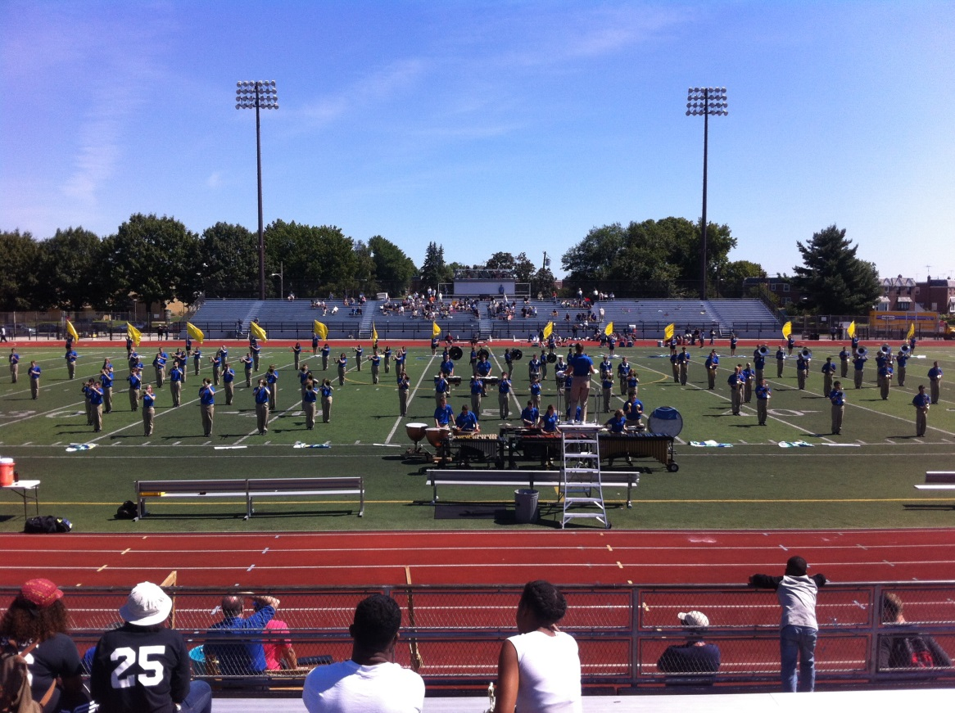
Image 1: Half-time show during Northeast vs. Council Rock North, September 9th, 2013.
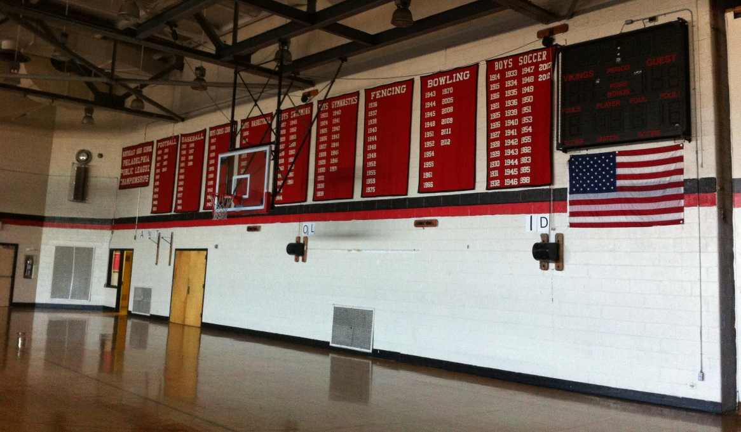
Image 2: One of three gymnasiums at Northeast High School.

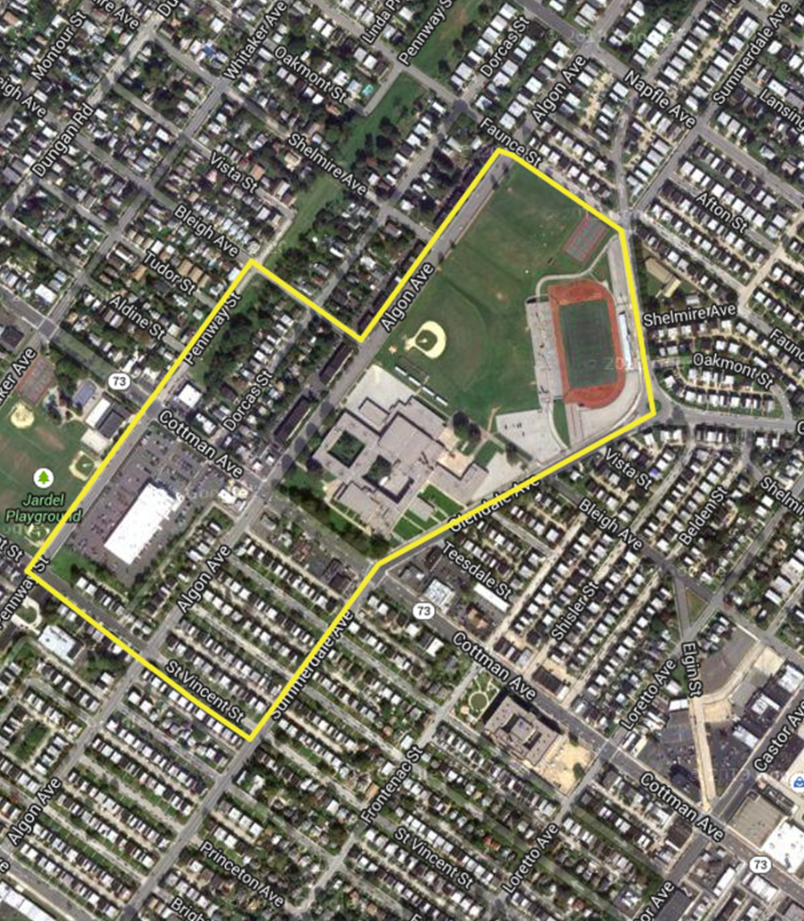
Image 3: Yellow line indicates perimeter of neighborhood walk.

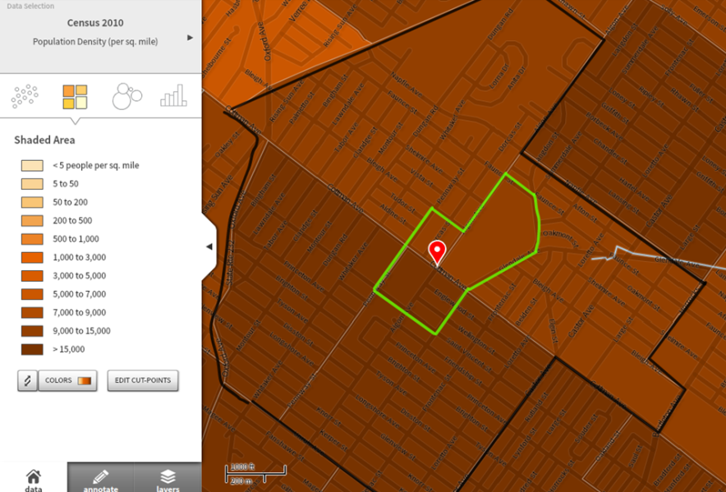
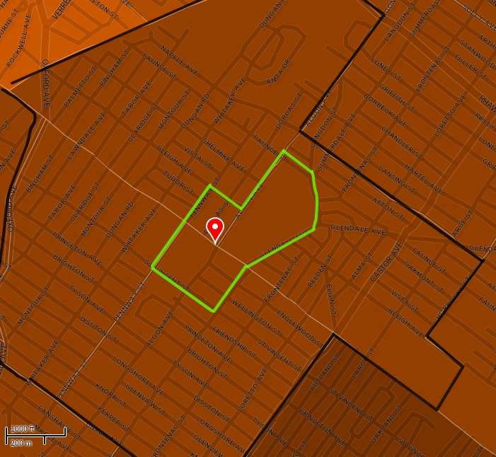
Image 4: Data of Population Density per square mile. Please enlarge the image in order to better see the scale located on the left hand side of the image. Black outline represents the four surrounding census tracts of Northeast High School. Green outline represents the perimeter of neighborhood walk (U.S. Census Bureau, 2013).
- Image on left shows population density from Census 2010.
- Image on right shows population density from Census 2000.
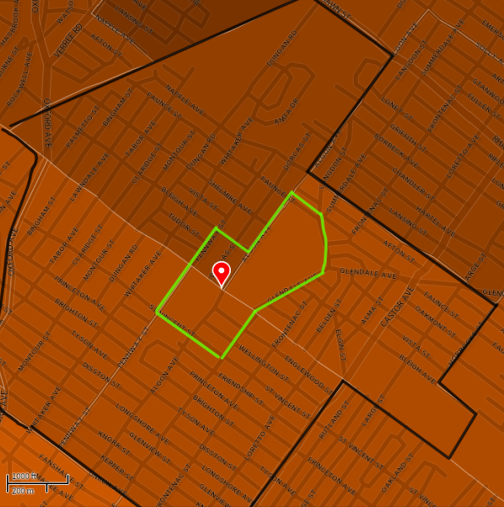
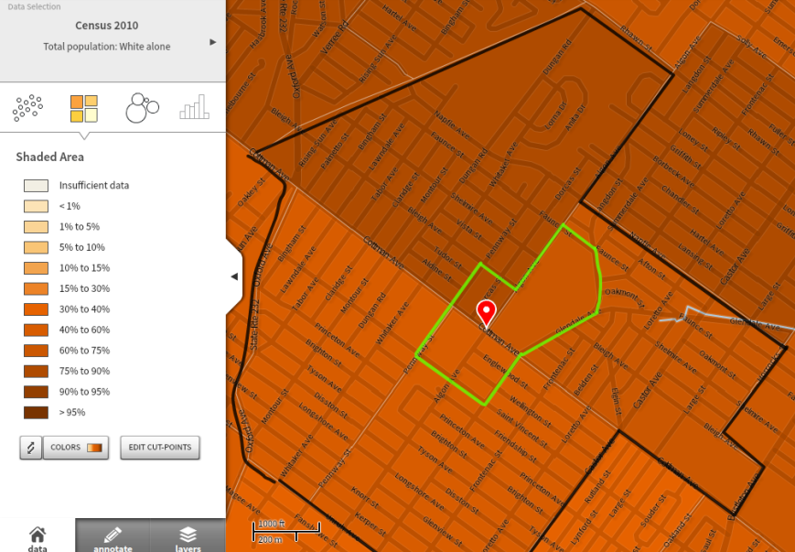
Image 5: Data portraying percent of White population in the total population. Black outline represents the four surrounding census tracts of Northeast High School. Green outline represents the perimeter of neighborhood walk (U.S. Census Bureau, 2013).
- Image on left shows percent of White population from Census 2010.
- Image of right shows percent of White population from Census 2000.
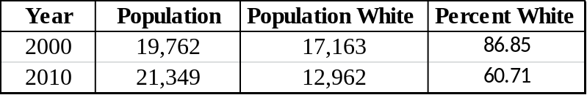
Table 1: Populations within the four surrounding census tracts of Northeast High School. Summarizes population numbers of Image 4 & 5 (U.S. Census Bureau, 2013).
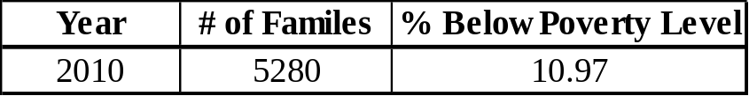
Table 2: Family income in 2010 below poverty level. Families that are included are those with presence of children under 18 years of age. Values are from the four surrounding census tracts of Northeast High School (U.S. Census Bureau, 2013).

References
Northeast High School Philadelphia (n.d.). Applied Visual & Interactive Design (AVID). Retrieved September 5, 2013 from http://nehs.phila.k12.pa.us/AVID/index.html.
Northeast High School Philadelphia (2011). Programs. Retrieved September 5, 2013 from http://www.nehs.phila.k12.pa.us/nehs-wp/?page_id=8
Northeast High School Philadelphia (2012). School Mission Statement. Retrieved September 5, 2013 from http://www.nehs.phila.k12.pa.us/nehs-wp/?p=1051
Northeast High School (Philadelphia) (2013). Wikipedia. Retrieved September 6, 2013 from http://en.wikipedia.org/wiki/Northeast_High_School_(Philadelphia)#Population).
Office of Accountability [PDF file] (2011). Northeast High School (Grades 9-12) 2011 Annual Report. Retrieved September 6th, 2013 from https://webapps.philasd.org/sp_files/annual_reports/8020_AnnualReport_2011.pdf.
Philadelphia Public School Notebook (2012). School Profiles: Northeast High School. Retrieved September 5, 2013 from http://thenotebook.org/content/northeast-high-school.
The School District of Philadelphia (2013). School Profile: Northeast High. School. Retrieved September 6, 2013 from https://webapps.philasd.org/school_profile/view/8020.
The School District of Philadelphia [PDF file] (March 18, 2013). Northeast High School: 2011 High School Performance Index Final Recalculated Scores. Retreived September 6, 2013 from https://webapps.philasd.org/sp_files/spi/8020_SPI_2011.pdf.
U.S. Census Bureau (2013). Social Explorer. Retrieved September 6, 2013 from http://www.socialexplorer.com/.

